**Rules:**

Choose your level and prepare as many steps within that level that you desire. (You do not have to learn every step within your level to participate.) You will pass off what you know to a Flute Scale Expert at MWFF. A “GOLD” medal will be presented to those that pass off ALL the steps within their level.

**Level 2**

**1 octave scales up to 2 sharps & 2 flats**

|  |  |  |  |  |  |
| --- | --- | --- | --- | --- | --- |
| **1 Octave Major Scale**  Up & Down  m=60 | C Major | G Major | D Major | F Major | Bb Major |
| **1 Octave Arpeggio in Root Position**  Up & Down  m=60 | C Major | G Major | D Major | F Major | Bb Major |
| **Long Tone for 8 seconds on a B’’** | | | | | |

**Level 1**

**Up to 1 Sharp & 1 Flat**

|  |  |  |  |
| --- | --- | --- | --- |
| **5 Note Major Scale**  Up & Down  m=60 | C Major | G Major | F Major |
| **3 Note Major Arpeggio**  Up & Down  m=60 | C Major | G Major | F Major |
| **Long Tone for 5 seconds on B’’** | | | |

**Level 4**

**1 octave scales in all 12 Major Keys**

|  |  |  |  |  |  |  |  |  |  |  |  |  |
| --- | --- | --- | --- | --- | --- | --- | --- | --- | --- | --- | --- | --- |
| **1 Octave Major Scale**  Up & Down  m=80 | C Major | G Major | D Major | A Major | E Major | B/  Cb Major | F#/  Gb  Major | C#/  Db  Major | Ab Major | Eb Major | Bb Major | F Major |
| **1 Octave Arpeggio in Root Position**  Up & Down  m=80 | C Major | G Major | D Major | A Major | E Major | B/  Cb Major | F#/  Gb  Major | C#/  Db  Major | Ab Major | Eb Major | Bb Major | F Major |
| **Chromatic Scale, 1 Octave, from C’’ to C’’’, m=80** | | | | | | | | | | | | |
| **Long Tone for 13 seconds on B’’** | | | | | | | | | | | | |

**Level 3**

**1 octave scales up to 4 sharps & 4 flats**

|  |  |  |  |  |  |  |  |  |  |
| --- | --- | --- | --- | --- | --- | --- | --- | --- | --- |
| **1 Octave Major Scale**  Up & Down  m=60 | C Major | G Major | D Major | A Major | E Major | F Major | Bb Major | Eb Major | Ab Major |
| **1 Octave Arpeggio in Root Position**  Up & Down  m=60 | C Major | G Major | D Major | A Major | E Major | F Major | Bb Major | Eb Major | Ab Major |
| **Chromatic Scale, 1 Octave, from C’’ to C’’’, m=60** | | | | | | | | | |
| **Long Tone for 10 seconds on B’’** | | | | | | | | | |

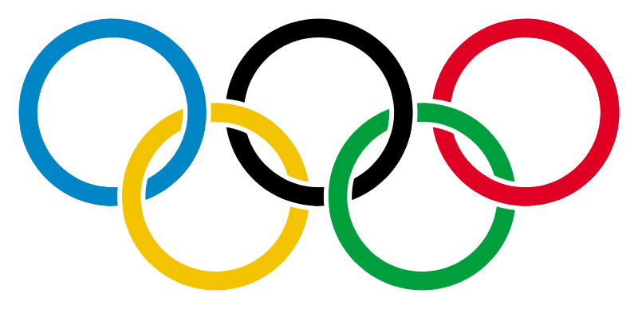



**Flute Olympic Scaling**

**Level 5**

**2 octave scales and arpeggios in all 12 Major Keys**

|  |  |  |  |  |  |  |  |  |  |  |  |  |
| --- | --- | --- | --- | --- | --- | --- | --- | --- | --- | --- | --- | --- |
| **2 Octave Major Scales**  Up & Down  m=80 | C | G | D | A | E | B/  Cb | F#/  Gb | C#/  Db | Ab | Eb | Bb | F |
| **2 Octave Arpeggios in Root Position**  Up & Down  m=80 | C | G | D | A | E | B/  Cb | F#/  Gb | C#/  Db | Ab | Eb | Bb | F |
| **Chromatic Scale,** 2 Octaves, from C’ to C’’’, m=80 | | | | | | | | | | | | |
| **Long Tone for 15 seconds on B’’** | | | | | | | | | | | | |

**Level 8 SPEED SCALING!!!!!**

All Major Scales, 2 Octaves, Slurred, Under 1 minute!

**Level 9 College AUDITION Pre-Prep!**

All major and melodic minor scales, 2 octaves, slurred in sixteenth notes, quarter note = 96 Three octave chromatic scale, single tongued at a tempo of quarter note = 96 or faster.

**Level 7**

**2 octave scales in all 12 Major Keys + 2 octave Harmonic and Melodic Minor Scales in all 12 keys**

|  |  |  |  |  |  |  |  |  |  |  |  |  |
| --- | --- | --- | --- | --- | --- | --- | --- | --- | --- | --- | --- | --- |
| **Major Scales with Major Arpeggios in Root Position**  2 Octaves  Up & Down  With 4 sixteenth notes m=80 | C | G | D | A | E | B/  Cb | F#/  Gb | C#/  Db | Ab | Eb | Bb | F |
| **Harmonic Minor Scales with Minor Arpeggios in Root Position**  2 octaves  Up & Down  With 2 eighths m=80 | A | E | B | F# | C# | G#/Ab | D#/Eb | A#/Bb | F | C | G | D |
| **Melodic Minor Scales with Minor Arpeggios in Root Position**  2 octaves  Up & Down  With 2 eighths m=80 | A | E | B | F# | C# | G#/Ab | D#/Eb | A#/Bb | F | C | G | D |
| **Chromatic Scale,** 3 Octaves, from C’ to C’’’’, 4 Sixteenths m=80 | | | | | | | | | | | | |
| **Long Tone for 20 seconds on B’’** | | | | | | | | | | | | |

**Level 6**

**2 octave scales and arpeggios in all 12 Major Keys + 1 octave Harmonic Minor Scales and arpeggios in all 12 keys**

|  |  |  |  |  |  |  |  |  |  |  |  |  |
| --- | --- | --- | --- | --- | --- | --- | --- | --- | --- | --- | --- | --- |
| **2 Octave Major Scales with Major Arpeggio in Root Position**  Up & Down  With 2 eighth notes m=80 | C | G | D | A | E | B/  Cb | F#/  Gb | C#/  Db | Ab | Eb | Bb | F |
| **Harmonic minor Scales with minor arpeggios in root position**  1 octave  Up & Down  m=80 | A | E | B | F# | C# | G#/Ab | D#/Eb | A#/Bb | F | C | G | D |
| **Chromatic Scale,** 3 Octaves, from C’ to C’’’’, 2 eighths m=80 | | | | | | | | | | | | |
| **Long Tone for 18 seconds on B’’** | | | | | | | | | | | | |